 | 12.1.37 Editors - Geometry Nodes Editor - Header - Add Menu - Volume - Primitives
Table of content
Detailed table of content 1
Add menu - Volume - Primitives 1
Volume Cube 1

Detailed table of content
Detailed table of content
Detailed table of content 1
Add menu - Volume - Primitives 1
Volume Cube 1
Inputs 1
Geometry 1
Density 1
Background 1
Min: 2

Add menu - Volume - Primitives
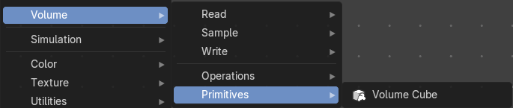
Here you find nodes to modify the volume.

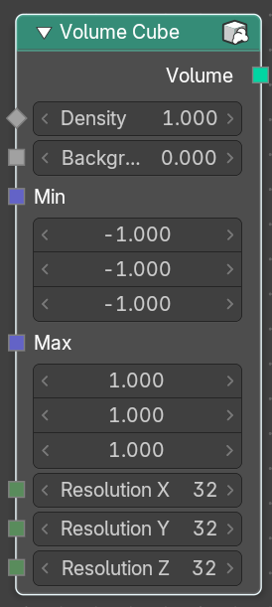
Volume Cube
The Volume Cube node generates a voxel based volume cube primitive that can be used for volume conversion to mesh in conjunction with the Volume to Mesh node.

Inputs

Geometry
Standard geometry input.

Density
Volume density per voxel. Higher values makes it more dense.

Background
Value per voxel outside the cube domain.

Min:
Minimum boundary of the volume cube.
Max:
Maximum boundary of the volume cube.
Resolution X
Number of volume voxules in the X axis.
Resolution Y
Number of volume voxules in the Y axis.
Resolution Z
Number of volume voxules in the Z axis.

